Machine Learning Safety
Exercise sheet 2

Exercise 2.1:
Safety Vocabulary
Define the following terms in your own words and give a concrete example from an
autonomous driving context for each:
1. Loss
2. Hazard
3. Risk

Answer
1. Loss – It is a bad outcome that system causes which results in harm.
For example, A pedestrian is injured because the vehicle fails to stop in time.
2. Hazard – A dangerous system state which can lead to a loss under certain conditions
For example, model fails to detect the pedestrian and the vehicle continues driving even though a pedestrian is in its path.
3. Risk - The combination of how likely a hazard is and how severe its consequences could be.
For example, the risk of collision increases during foggy weather because pedestrian detection becomes less reliable.

Exercise 2.2: ODD Specification
Based only on the system description in the course Roadmap (you have not yet seen the
training data), define the Operational Design Domain (ODD) for the CARLA system.
Cover at least the following dimensions: weather, lighting, camera condition, scene type, and vehicle speed.
For each dimension, state:
1. The operating conditions (where the system is considered valid).
2. The non-operating conditions (where it is not).
3. How an ODD violation could be detected at runtime

Answer

Dimension | Operating Conditions | Non-Operating Conditions | Runtime ODD Violation Detection
Weather | Sunny weather, daytime conditions | Heavy rain, fog, snow | Changes in visibility or weather conditions observed from camera input
Lighting | Daytime lighting | Nighttime or very low-light conditions | Very dark camera images or reduced visibility
Camera Condition | Forward-facing RGB camera functioning normally | Blocked, damaged, or unclear camera view | Distorted or unclear camera images
Scene Type | Urban roads and mapped intersections | Environments different from urban roads or unmapped areas | Unexpected road scenes or intersections
Vehicle Speed | Speeds up to 50 km/h | Speeds above intended operating range | Vehicle speed exceeding intended operating conditions

Exercise 2.3: Losses
STPA begins by identifying the losses that must be prevented- unacceptable outcomes
involving harm to people, property, or the environment.
For each loss, identify its ID (L-1, L-2, ...), briefly describe it, and explain why it is
unacceptable:

Answer
ID | Loss Description | Why Unacceptable
L-1 | Injury or death of a pedestrian | Failure to detect pedestrians could lead to severe accidents and even loss of life
L-2 | Collision with another vehicle | Vehicle collisions can cause injuries and major traffic disruptions
L-3 | Damage to public or private property | Crashes involving buildings, traffic infrastructure, or parked vehicles can cause financial, safety and legal consequences.
L-4 | Violation of traffic laws or unsafe driving behaviour | Ignoring traffic rules can create dangerous situations and reduce trust in autonomous systems.

Exercise 2.4 Hazards
A hazard is a system state that, combined with worst-case environmental conditions, can lead to a loss. Hazards are properties of the system, not of individual components.
1. Identify at least four system-level hazards (H-1, H-2, ...) for the CARLA system.
2. For each hazard, state which loss(es) from Exercise 2.3 it can lead to.
3. Rate each hazard’s likelihood (low / medium / high) and its severity (low / medium
/ high).
Fill in the following table:

Answer:
ID | Hazard | Loss(es) | Likelihood | Severity
H-1 | Pedestrian is detected too late for safe braking | L-1 | Medium | High
H-2 | Vehicle fails to stop when another vehicle is directly ahead | L-2 | Medium | High
H-3 | Camera input becomes unclear or obstructed | L-1, L-2, L-4 | Medium | High
H-4 | Emergency braking is triggered unnecessarily | L-2, L-3 | Low | Medium

Exercise 2.5: Control Structure Diagram
Draw the control structure for the CARLA system. Your diagram must include:
• All components listed in the system description (camera, perception models, distance
oracle, planning module, actuators, human operator).
• Control actions (solid arrows): commands flowing from controllers to controlled
processes (e.g., “brake command”).
• Feedback (dashed arrows): information flowing back (e.g., “perception labels”,
“distance estimates”, “vehicle speed”).

Answer
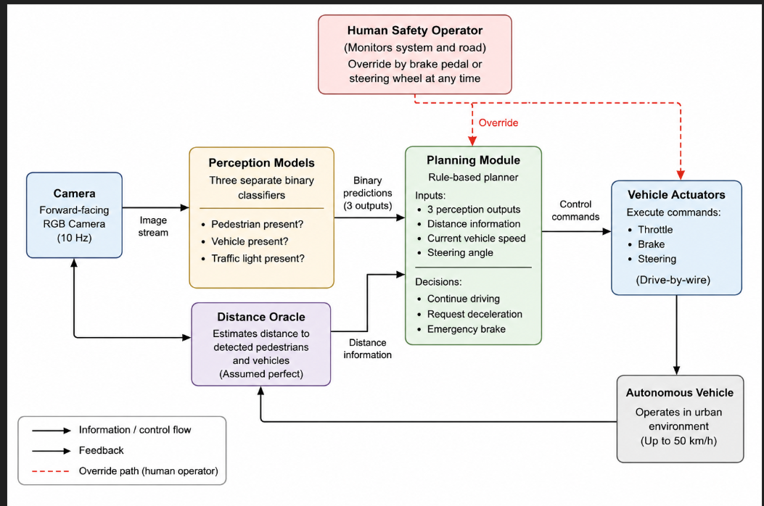

Exercise2.6: Unsafe Control Actions (UCAs)
Using your control structure, identify unsafe control actions for at least two different
controllers. For each UCA, also indicate which hazard(s) from Exercise 2.4 it could cause or lead to (reference them by ID, e.g., “H-1”, “H-2”).
For each controller, consider all four UCA types:
1.Not provided-a required action is missing.
2.Provided unsafely- the action is issued when it should not be.
3.Wrong timing/order- too early, too late, or out of sequence.
4.Wrong duration- applied too long or stopped too early.

Answer
ID | Controller | Control Action | UCA Type | Hazard(s) | Unsafe Scenario
UCA-1 | Planning Module | Brake command | Not provided | H-1 | The planner does not issue braking even though a pedestrian is detected within critical distance.
UCA-2 | Planning Module | Continue driving | Provided unsafely | H-3 | The planner continues autonomous driving even though the camera image is unclear or obstructed.
UCA-3 | Planning Module | Emergency brake | Wrong timing/order | H-1, H-2 | Braking is triggered too late to avoid a collision.
UCA-4 | Planning Module | Emergency brake | Provided unsafely | H-4 | Emergency braking is activated even though no obstacle exists.
UCA-5 | Human Operator | Manual override | Wrong duration | H-2 | The operator continues manual override for too long and destabilizes vehicle behaviour.
UCA-6 | Human Operator | Manual override | Not provided | H-1, H-2 | The operator does not intervene when unsafe system behaviour occurs.
UCA-7 | Human Operator | Brake intervention | Wrong timing/order | H-1 | The operator reacts too late to avoid collision with a pedestrian.
UCA-8 | Human Operator | Steering/brake override | Provided unsafely | H-2, H-4 | The operator unnecessarily overrides the system and creates unsafe vehicle behaviour.

Exercise 2.7
For each UCA from Exercise 2.6, derive at least one safety constraint - a requirement that, if satisfied, prevents the UCA from occurring or limits its consequences.
Classify each constraint as either:
• Model-level - can be verified by testing or evaluating the corresponding perception model (this is what you will do in Sheets 4–9).
• System-level - requires a design measure beyond the model (e.g., redundancy, operator protocol, fallback behavior).

Answer
UCA | Safety Constraint | Level | Verification
UCA-1 | The planner must issue braking when a pedestrian is detected within critical stopping distance. | System-level | Scenario testing and braking evaluation
UCA-2 | Autonomous driving must not continue when the camera input is unclear or obstructed. | System-level | ODD violation testing
UCA-3 | Emergency braking commands must be issued within a safe response time. | Model-level | Latency and timing evaluation
UCA-4 | Emergency braking should only be activated when obstacle detection is reliable. | Model-level | Evaluation on validation and test datasets
UCA-5 | Manual override should safely return vehicle control without destabilizing behaviour. | System-level | Simulation and operator testing
UCA-6 | The operator must be able to intervene whenever unsafe system behaviour occurs. | System-level | Human intervention testing
UCA-7 | Unsafe situations must be communicated early enough for operator reaction. | System-level | Reaction-time evaluation
UCA-8 | Manual override actions should not create unsafe steering or braking behaviour. | System-level | Simulation-based testing

Exercise 2.8
For each UCA from Exercise 2.6, identify at least one causal scenario - a specific mechanism or sequence of events that could cause the UCA to occur in practice.
For each scenario, describe:
- The causal factor: What component failure, misunderstanding, or adverse condition triggers the UCA?
- Why it occurs: What is the root cause or underlying reason?
- Connection to constraint: Which safety constraint from Exercise 2.7 is designed to prevent or mitigate this scenario?

UCA | Causal Scenario | Root Cause | Related Constraint
UCA-1 | The planner does not brake because the pedestrian detector reports “no pedestrian”. | Incorrect perception output from the model. | The planner must issue braking when a pedestrian is detected within critical stopping distance.
UCA-2 | Autonomous driving continues even though the camera image is unclear. | Camera obstruction or reduced visibility is not detected. | Autonomous driving must not continue when the camera input is unclear or obstructed.
UCA-3 | Emergency braking is triggered too late to avoid collision. | Detection or processing delay in the perception pipeline. | Emergency braking commands must be issued within a safe response time.
UCA-4 | Emergency braking is activated even though no obstacle exists. | False positive perception output from the model. | Emergency braking should only be activated when obstacle detection is reliable.
UCA-5 | The operator continues manual override for too long and destabilizes vehicle behaviour. | Human error or incorrect judgement during intervention. | Manual override should safely return vehicle control without destabilizing behaviour.
UCA-6 | The operator does not intervene during unsafe system behaviour. | Attention lapse or delayed human reaction. | The operator must be able to intervene whenever unsafe system behaviour occurs.
UCA-7 | The operator reacts too late to prevent pedestrian collision. | Unsafe situation is recognized too late by the operator. | Unsafe situations must be communicated early enough for operator reaction.
UCA-8 | The operator unnecessarily overrides the system and causes unsafe behaviour. | Misunderstanding of system state or unnecessary intervention. | Manual override actions should not create unsafe steering or braking behaviour.

Exercise 2.9
Review the safety constraints you derived in Exercise 2.7 and the causal scenarios from Exercise 2.8. For each model-level constraint, identify which future exercise sheet will provide evidence (refer to the Course Roadmap). For each system-level constraint, briefly describe what kind of evidence or argument you would need- even though you cannot run an experiment for it in this course.
Answer
Safety Constraint | Type | Evidence / Related Exercise Sheet
The planner must issue braking when a pedestrian is detected within critical stopping distance. | System-level | Simulation testing and planner behaviour analysis would be required.
Autonomous driving must not continue when the camera input is unclear or obstructed. | System-level | ODD violation detection and monitoring mechanisms would be needed.
Emergency braking commands must be issued within a safe response time. | Model-level | Sheet 4 (Testing I) through latency and performance evaluation.
Emergency braking should only be activated when obstacle detection is reliable. | Model-level | Sheet 4 (Testing I) using precision, recall, and confusion matrices.
Manual override should safely return vehicle control without destabilizing behaviour. | System-level | Human operator testing and simulation-based evaluation would be required.
The operator must be able to intervene whenever unsafe system behaviour occurs. | System-level | Evidence would require operator monitoring studies and safety protocols.
Unsafe situations must be communicated early enough for operator reaction. | System-level | Human reaction-time evaluation and interface testing would be needed.
Manual override actions should not create unsafe steering or braking behaviour. | System-level | Simulation testing and operational safety procedures would be required.

